Rural Readings

(Mary E SEymour memorial free library & cassadga branch library Newsletter)
Winter Continues On and On….
February is Library Lovers Month! As the winter drags on, now is the perfect time to make use of all the benefits of our libraries. Make sure to take a look at our upcoming events to conquer that cabin fever!
…
Hours:
Mary E. Seymour (Stockton):
Tue & Thurs: 1pm-7pm
Fri: 1pm-5pm
Sat: 10am-2pm
Cassadaga Branch:
Mon & Wed: 1pm-7pm
Fri: 9am-12pm
Sat: 10am-2pm

We want to thank you all for your continued support and patronage!

W

February 2020

Recent Events:

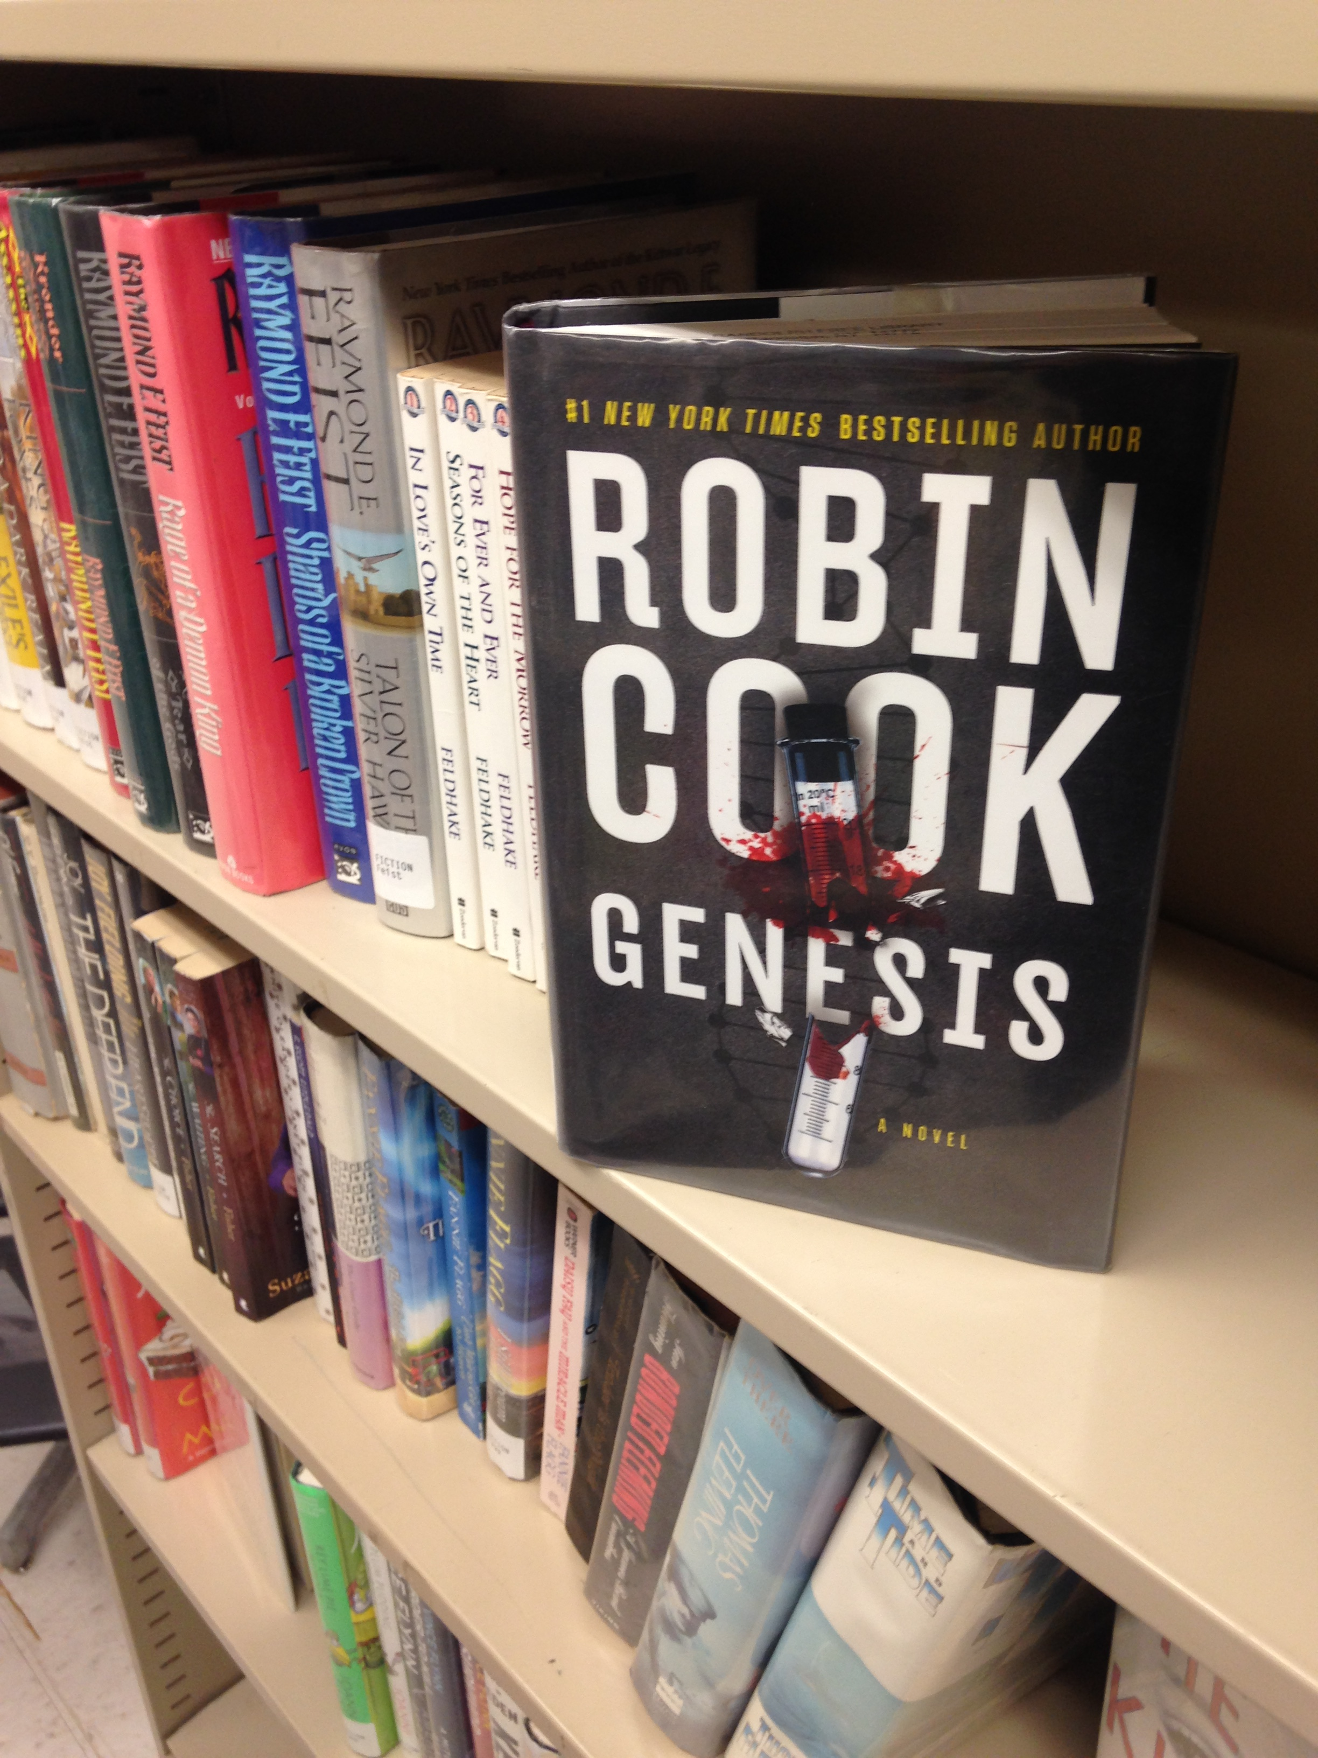
Cassadaga Book Club:
A new adult book club has formed at the Cassadaga Branch Library. Their first meeting was held January 25th,2020. They plan to meet the last Saturday of every month at 2pm at the Cassadaga Branch Library. The book they are currently reading this month is Genesis by Robin Cook, which will be discussed over coffee and cookies. The next book they plan to read is still to be determined. The group is new, open to all adults and is actively seeking members.

upcoming events This Month:
At Stockton:
Monthly:
Feb 21st: Mary’s Book Club 3pm (3rd Friday of every month) *They are currently reading Us Against You by Fredrik Backman and will be reading The No. 1 Ladies’ Detective Agency by Alexander McCall Smith next month*
Feb 15th: Game Day 10am-2pm (This event is usually held the 2nd Saturday of every month, but will be moved ahead because of the Winter Festival on February 8th)
Special:
Feb 1st: Take Your Child to the Library Day 10am-2pm *All children get a free gift for coming to the library on this day*
Feb 14th: Valentine Cupcake Decorating Party 1pm-5pm (cupcakes and decorating supplies provided)
*See other side for more events*

At Cassadaga:
Monthly:
Feb 1st: Nerf War 2pm-4:30pm (1st Saturday of the month) *Bring your own nerf weapons, bullets and gear. Snacks and drinks will be provided*
Feb 29th: *NEW GROUP!* Cassadaga Book Club 2pm-3pm (The last Saturday of every month)
Weekly:
Fridays at 10:30am: Story Time! *Join us for stories and crafts!*
Special:
Feb 1st: Take Your Child to the Library Day 10am-2pm *All children get a free gift for coming to the library on this day*
Feb 8th: “For the Birds” Nature Program 10am-11am *a Winter Festival event that will include games and crafts*
Feb 14th: A Special Valentine Story Time 10am-11am *Join us for cookie and card decorating!*

(Be Sure to check our Website and Facebook Page For Any News and Updates on Upcoming Events)

available services: Access to thousands of printed books, ebooks, audio books, magazines and dvds for checkout. Fax, scanning and printing services are also available, as well as free wifi and public computers.
Tell us what you think: Fill out a survey at either building to register your opinions of the library – what works, what doesn’t and what can we do to improve your library experience.
Please consider donating to your local library. Any amount helps and is 100% tax deductible.
Contact Us
22 N Main St, PO Box 128, Stockton
595-3323
18 Maple St, PO Box 384, Cassadaga
595-3822
seymourlibrary@cclslib.org
stocktonlibraries.org

