Rural Readings

(Mary E SEymour memorial free library & cassadga branch library Newsletter)

January 2020
The New Year Brings Many Changes!
There have been many changes at our libraries in 2019, starting with a new Library Director: Hannah Abram of South Stockton, who started back in May,.
We also had funding cut that made us have to shorten our hours through November and December. However, through continued donations and fundraising, both our libraries are able to return to our regular hours beginning this January:
Mary E. Seymour (Stockton):
Tue & Thurs: 1pm-7pm
Fri: 1pm-5pm
Sat: 10am-2pm
Cassadaga Branch:
Mon & Wed: 1pm-7pm
Fri: 9am-12pm
Sat: 10am-2pm
We want to thank you for all of your continued generosity and support!

W

Recent Events:
Light Up Cassadaga
In December we had wonderful turn out at the Library Open House during the Light Up Cassadaga event that was organized by the Citizens for a Better Cassadaga. With almost 200 people, we enjoyed crafts, cookies and hot apple cider. There was also free books for both children and adults alike!
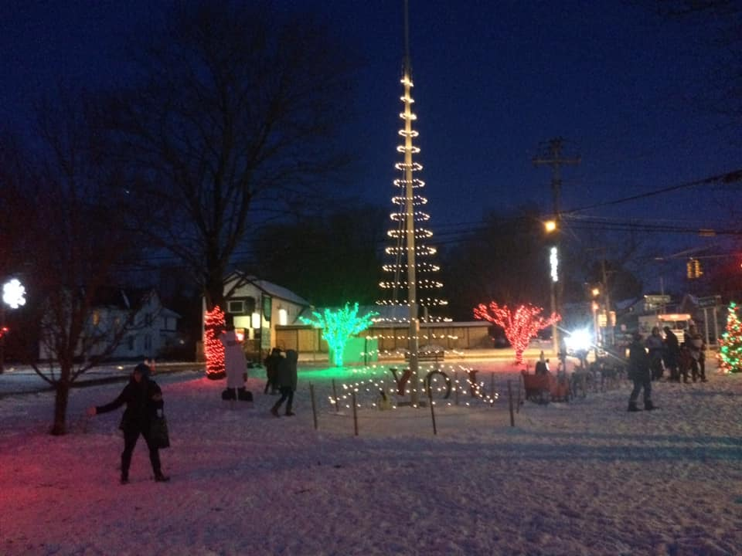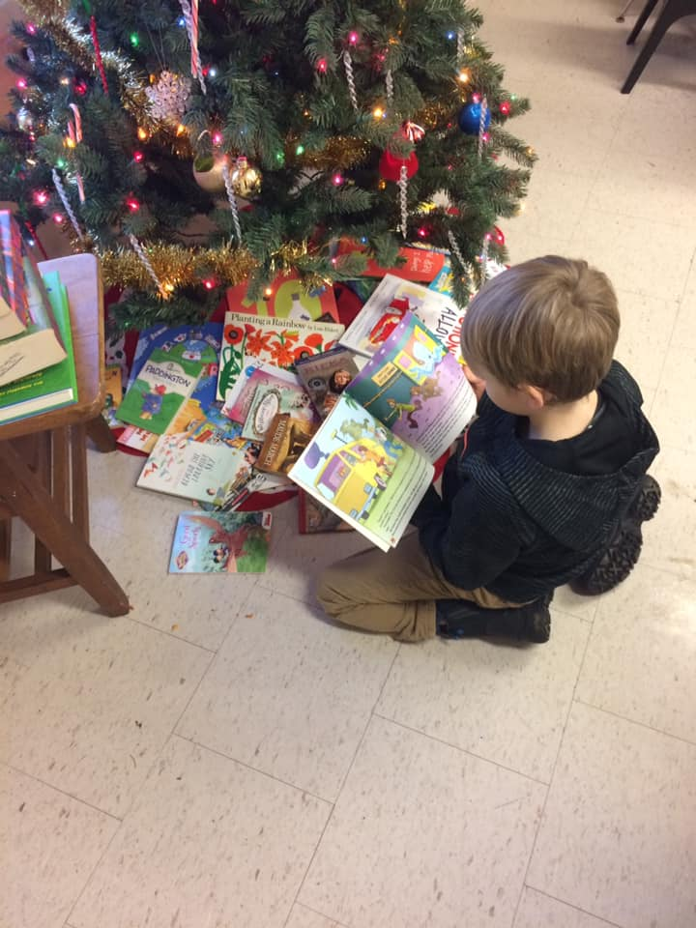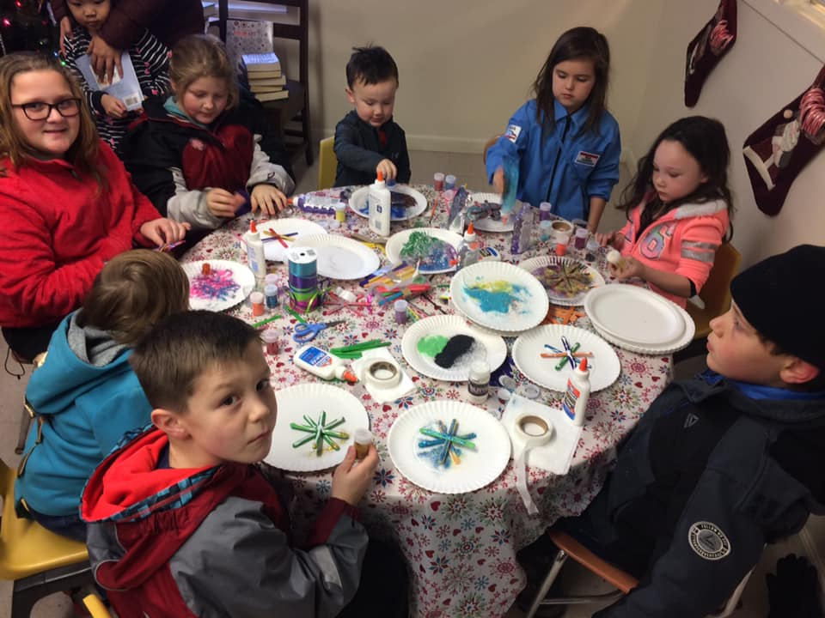

GAME DAY!
We are hosting a new event held every second Saturday of the month, featuring board games and snacks. We had a wonderful holiday party on the 14th of December with free books for the children of our community as well as snacks and hot chocolate!
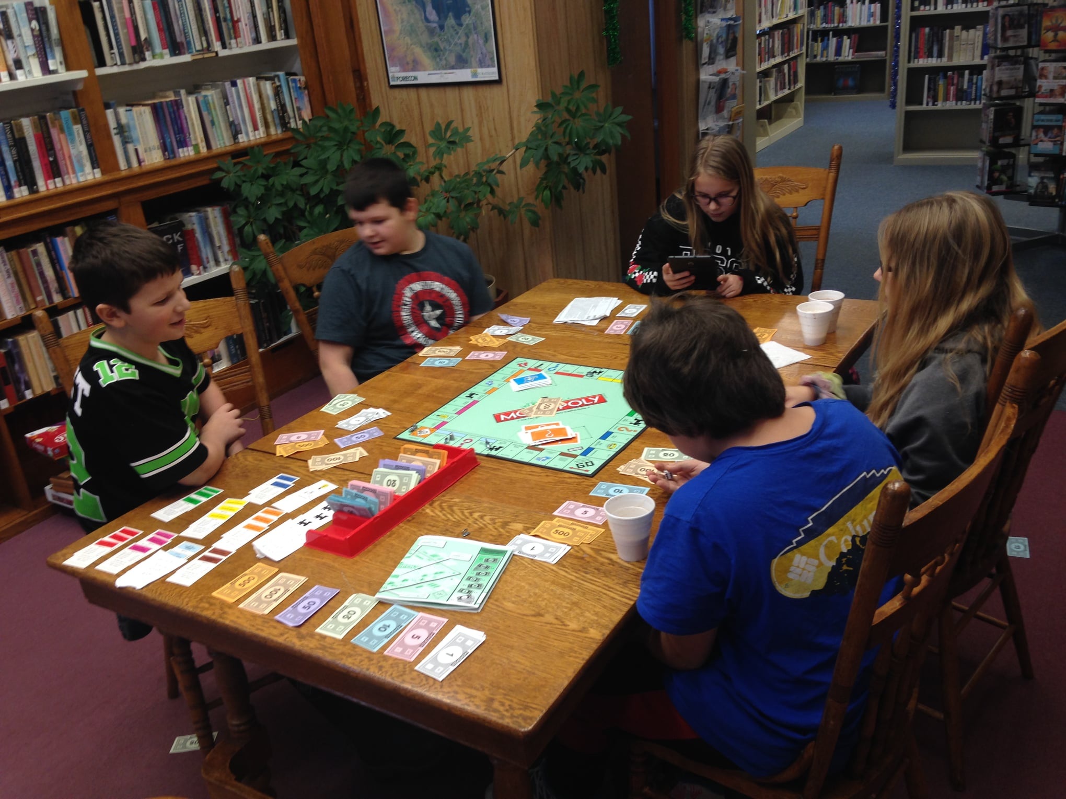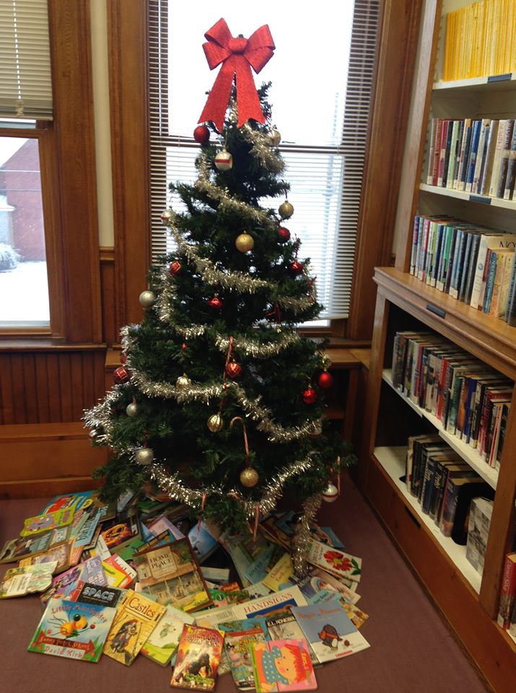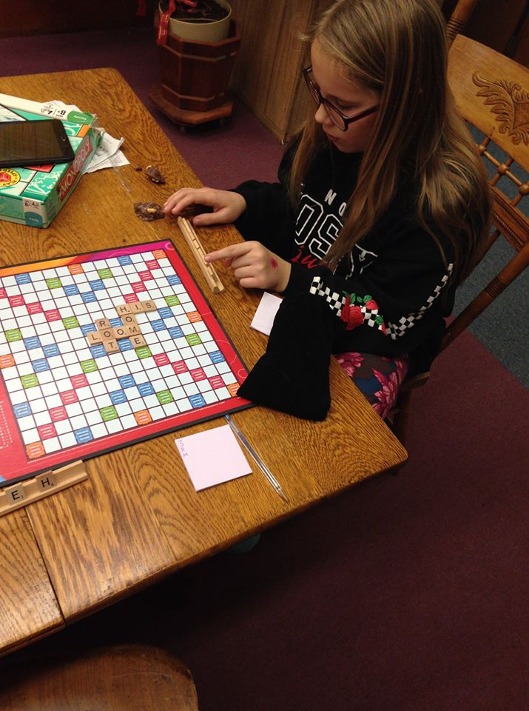

upcoming events This Month
At Stockton:
Monthly:
Jan 17th: Mary’s Book Club 3pm (Every 3rd Friday of the month)
Jan 11th: Game Day 2pm-4pm (Every 2nd Saturday of the Month)
At Cassadaga:
Monthly:
Jan 4th: Nerf War, 2pm-4:30pm (Every 1st Saturday of the month)
Jan 25th: *NEW GROUP!* Cassadaga Book Club 2pm-3pm (Every 4th Saturday of the month)

(Be Sure to check our Website and Facebook Page For Any News and Updates on Upcoming Events)

available services:
Access to thousands of print and ebooks, audio books, magazines, dvds for checkout. Fax, scanning and printing services available, as well as free wifi and public computers.

Tell us what you think:
Fill out a survey at either building to register your opinions of the library – what works, what doesn’t and what can we do to improve your library experience.

Please consider donating to your local library. Any amount helps and is tax deductible.
Contact Us
22 N Main St, PO Box 128, Stockton
595-3323
18 Maple St, PO Box 384, Cassadaga
595-3822
seymourlibrary@cclslib.org
stocktonlibrary.weebly.com

