Rural Readings

(Mary E SEymour memorial free library & cassadga branch library Newsletter)

March 2020
Spring Fever!
With winter coming to a slow end, we at the libraries can’t wait to anticipate spring and summer, especially for our system wide Summer Reading Program. Be on the lookout for news and events on our website and Facebook page for the warmer days ahead…
Hours:
Mary E. Seymour (Stockton):
Tue & Thurs: 1pm-7pm
Fri: 1pm-5pm
Sat: 10am-2pm
Cassadaga Branch:
Mon & Wed: 1pm-7pm
Fri: 9am-12pm
Sat: 10am-2pm
We want to thank you all for your continued support and patronage!

W

Recent Events:

“For the Birds”:

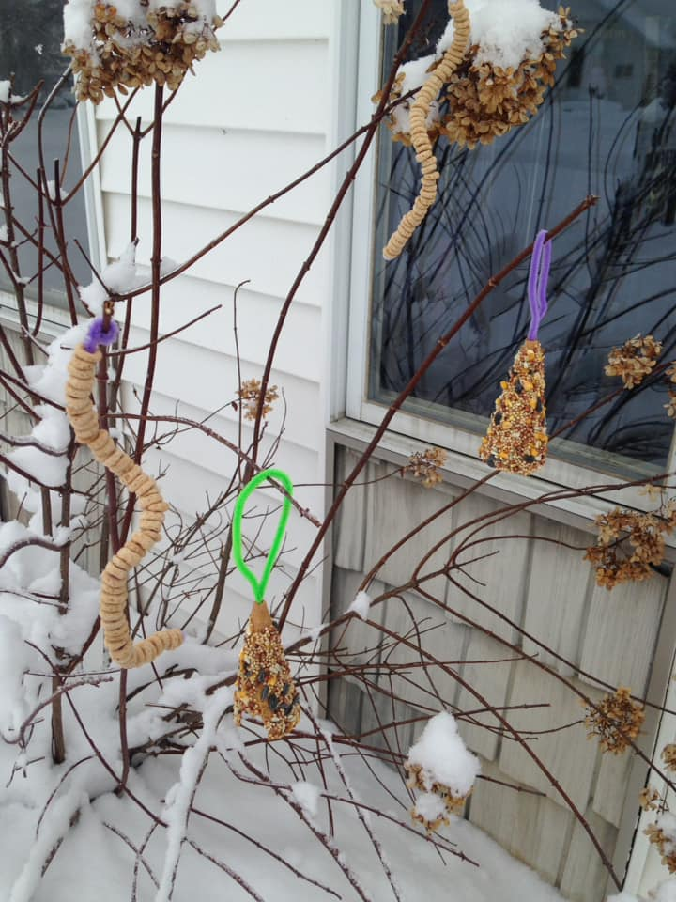
During the Cassadaga Winter Festival, the libraries and the Citizens for a Better Cassadaga hosted the nature program: “For the Birds” presented by Melanie Smith of The Roger Tory Peterson Institute. The program was held at Cassadaga Branch Library. Smith told the story of Roger Tory Peterson and presented fun games such as “Birdo” a bird version of bingo. Children enjoyed making bird feeders as a craft after the program. There was nearly seventy-five adults and children in attendance.
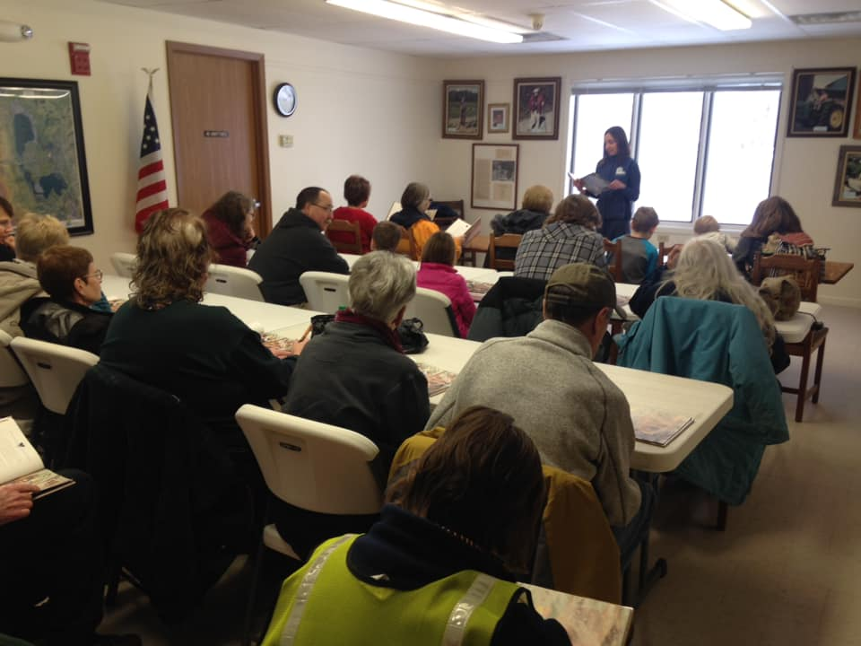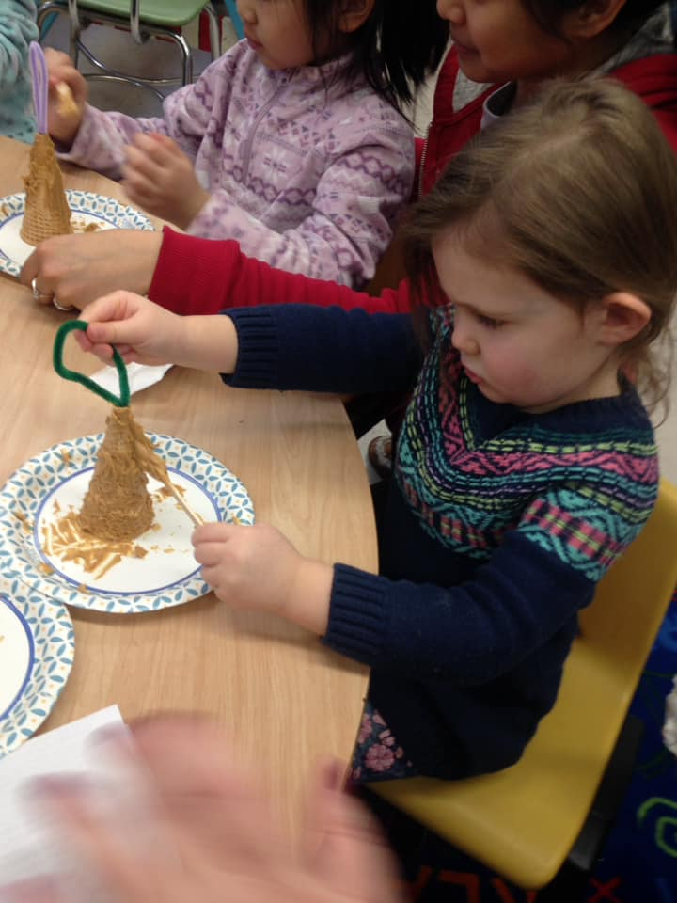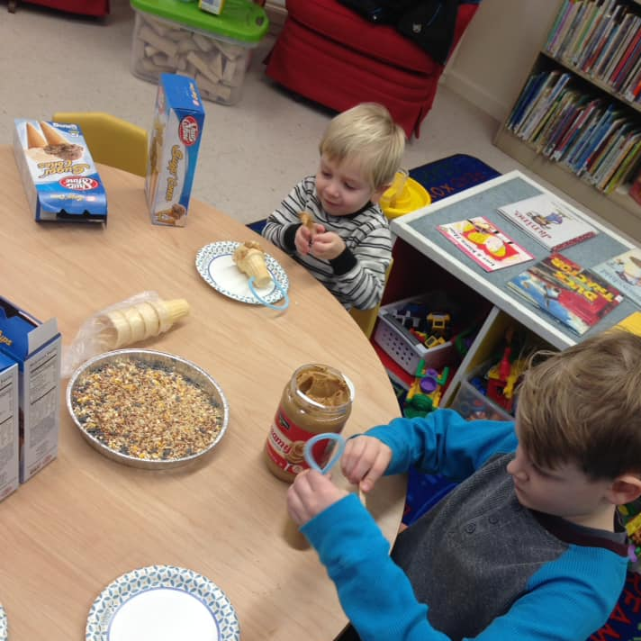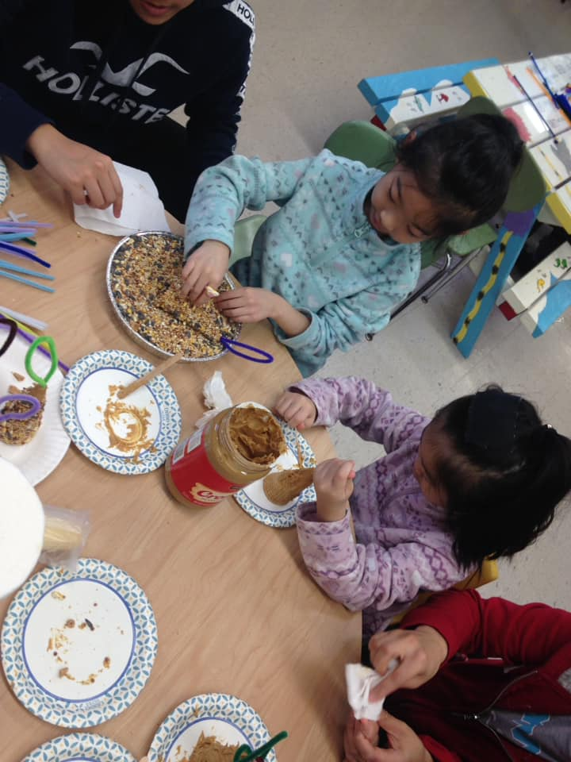

Census 2020:
Everybody Counts! The 2020 Census in upon us! Starting March 12th through July 31st the survey can be taken online, by phone or a paper survey can be taken through the mail. Our libraries are proud to promote the Census so that everybody gets counted.

(See other side for upcoming events)

upcoming events This Month:
At Stockton:
Monthly:
March 14th: Game Day 10am-2pm (every second Saturday of the month from Nov-April)
March 20th: Mary’s Book Club 3pm-4pm (Every third Friday of the month) *They are currently reading The No. 1 Ladies’ Detective Agency by Alexander McCall Smith*
At Cassadaga:
Monthly:
March 7th: Nerf War 2pm-4pm (Every first Saturday of the month) *Bring your own nerf weapons, bullets and gear. Snacks and drinks will be provided*
March 28th: *NEW GROUP!* Cassadaga Book Club 2pm-3pm (Every last Saturday of the month). *They are currently reading The Starless Sea by Erin Morgenstern*
Weekly:
Story Time: Fridays at 10:30am. *Join us for stories and crafts! Ages: 0-6, but all children are welcome!* March 13th will be a special St. Patrick’s Day themed Story Time! And March 20th will be a special First Day of Spring themed Story Time.
Special:
March 2nd: Dr. Seuss’ Birthday! Every child who comes in and checks out a book will be featured in a drawing for a Dr. Seuss themed prize!
  - (Be sure to check our website and Facebook Page for any future events or updates)
available services: Access to thousands of printed books, ebooks, audio books, magazines and dvds for checkout. Fax, scanning and printing services are also available, as well as free wifi and public computers.
Tell us what you think: Fill out a survey at either building to register your opinions of the library – what works, what doesn’t and what can we do to improve your library experience.
Please consider donating to your local library. Any amount helps and is 100% tax deductible.

Contact Us
22 N Main St, PO Box 128, Stockton
595-3323
18 Maple St, PO Box 384, Cassadaga
595-3822
seymourlibrary@cclslib.org
stocktonlibraries.org

