rural Readings
(Mary E SEymour memorial free library & cassadga branch library Newsletter)

We are Open!
As of July 8th, both libraries will be open to the public with limited access. Please be sure to read and follow the new safety protocols while visiting the library.
…
New Hours:
Mary E. Seymour Memorial Free Library (Stockton):
Tuesday: 1pm-7pm
Thursday: 1pm-7pm
Saturday: 10am-4pm
Cassadaga Branch Library:
Monday 1pm-7pm
Wednesday: 1pm-7pm
Friday: 10am-4pm

We want to thank you all for your continued support and patronage!

W

July 2020

Recent Events:

We are OPEN:
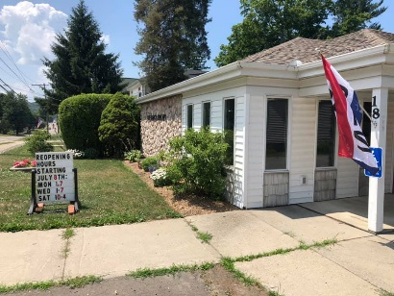
Beginning July 8th we are reopening to the community with limited access according to the New York State Guidelines in prevention of Covid-19.
Library Hours Beginning 7/8/2020:
* Liable to change during Reopening Phases, please check our website (stocktonlibraries.org) and Facebook Page (Stockton & Cassadaga Libraries) for more updates. *
Mary E. Seymour Memorial Free Library (Stockton):
Tuesday: 1pm-7pm
Thursday: 1pm-7pm
Saturday: 10am-4pm
Cassadaga Branch Library:
Monday 1pm-7pm
Wednesday: 1pm-7pm
Friday: 10am-4pm
Please be aware of the following safety protocols that will be required for patrons while visiting the libraries once we have reopened:
• Masks MUST be worn by patrons within the libraries at all times. This is a requirement!
- Only 6 patrons within the library at a time.
- Patrons must do their best to remain 6 feet apart from fellow patrons.
- All borrowed materials must be returned in the book drop, not at the front desk.
- Patrons will be requested to not use library furniture unless absolutely necessary.
- Only 1 patron within a library aisle at a time.
- Patrons will be encourage to visit the library for no more than 1 hour.
- If a Patron is to pick up a book or any library material without checking it out, they must bring it to the front desk for sanitation.
- Patrons must sign up at the front desk to use computers or printers and are only permitted an hour of use. They must also request headphones and return to the front desk when finished to be sanitized.
- Patrons must request key to use the bathroom (at Cassadaga Branch Library)
- Children under 13 must have an adult to accompany them into the library.
Curbside Pick Up is still available for those who are not comfortable returning to the libraries just yet.
We look forward to seeing you in the libraries again!

upcoming events This Month:
(All in-person programs, gatherings, clubs, and events hosted, organized and sponsored by the libraries are still prohibited at this time)
Weekly:
Online Story Time and Craft Time. Videos posted every Friday on our Facebook Page (Stockton & Cassadaga Libraries)!
Special:
Online Summer Reading Program! Be sure to check out our READsquared site (http://stocktonlibrariesny12.readsquared.com/) to register for our Summer Reading Program! There will be prizes and giveaways for our most active readers.

Please consider donating to your local library. Any amount helps and is 100% tax deductible.
Contact Us

595-3323

18 Maple St, PO Box 384, Cassadaga
595-3822
director@stocktonlibraries.org

