Rural Readings

Mary E SEymour memorial free library & cassadga branch library Newsletter

August 2020
stay safe and healthy!
We want to thank all our patrons for their continued support during this challenging time. Please remember while visiting the libraries to wear a mask, keep 6 feet away from fellow patrons, and to sanitize and wash your hands regularly.
Also, please take note of our current hours during the pandemic:

Mary E. Seymour Memorial Free Library (Stockton):
Tuesday: 1pm-7pm
Thursday: 1pm-7pm
Saturday: 10am-4pm

…

Cassadaga Branch Library:
Monday 1pm-7pm
Wednesday: 1pm-7pm
Friday: 10am-4pm

We want to thank you for all of your continued generosity and support!

W

Recent Events:
REOPENING
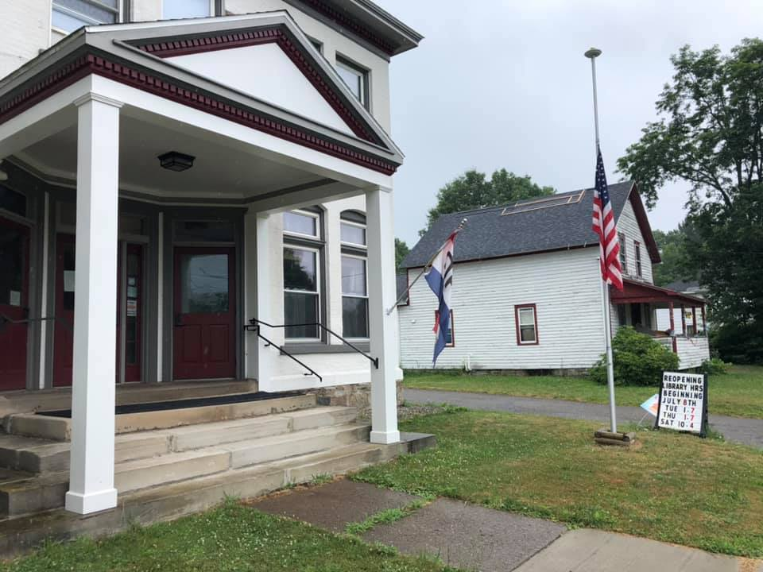
Since reopening last month with restrictions, our libraries have been so pleased to see the return of our patrons and to have them follow our safety procedures to help keep our community safe.

ONLINE FUN
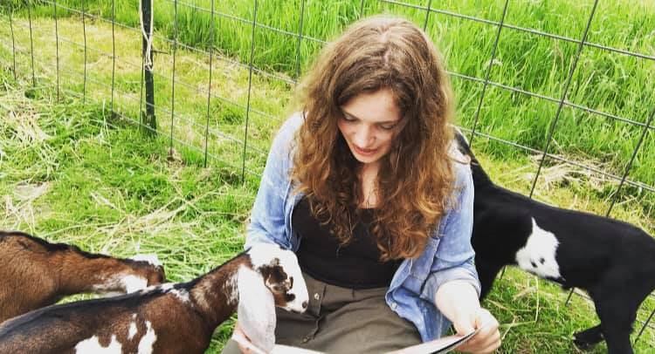
While gatherings are still restricted at the libraries, Online Story Time and Summer Reading Crafts are available! We have supply kits also available for any craft you and your little ones would like to make at home! Email us or call us to make a request for supply kits (Look under Contact Us at the bottom of the newsletter)! July and August Story Time features numerous animal guests! Videos are posted every weekend on our Facebook Page (Stockton & Cassadaga Libraries)!

upcoming events This Month:
(All in-person programs, gatherings, clubs, and events hosted, organized or sponsored by the libraries are still prohibited at this time)
Weekly:
Online Story Time and Craft Time. Videos posted every weekend on our Facebook Page (Stockton & Cassadaga Libraries)!
Special:
Online Summer Reading Program! Be sure to check out our READsquared site (http://stocktonlibrariesny12.readsquared.com/) to register for our Summer Reading Program! There will be prizes and giveaways for our most active readers.

Please consider donating to your local library. Any amount helps and is 100% tax deductible.
Contact Us
22 N Main St, PO Box 128, Stockton
595-3323
18 Maple St, PO Box 384, Cassadaga
595-3822
director@stocktonlibraries.org
www.stocktonlibraries.org

