Rural Readings

Mary E SEymour memorial free library & cassadga branch library Newsletter

SEPTEMBER 2020
stay safe and healthy!
We want to thank all our patrons for their continued support during this challenging time. Please remember while visiting the libraries to wear a mask, keep 6 feet away from fellow patrons, and to sanitize and wash your hands regularly.
Also, please take note of our return to normal hours:

Mary E. Seymour Memorial Free Library (Stockton):
Tuesday: 1pm-7pm
Thursday: 1pm-7pm
Friday: 1-5pm
Saturday: 10am-2pm

…

Cassadaga Branch Library:
Monday 1pm-7pm
Wednesday: 1pm-7pm
Friday: 9am-12pm
Saturday: 10am-2pm

We want to thank you for all of your continued generosity and support!

W

Recent Events:
RESUMING NORMAL HOURS
Beginning September 1st, 2020 we will be resuming our normal hours at both libraries. Please take note!
Mary E. Seymour Memorial Free Library:
Tuesday: 1pm-7pm
Thursday: 1pm-7pm
Friday: 1pm-5pm
Sat: 10am-2pm
Cassadaga Branch:
Monday: 1pm-7pm
Wednesday: 1pm-7pm
Friday: 9am-12pm
Saturday: 10am-2pm
ONLINE FUN
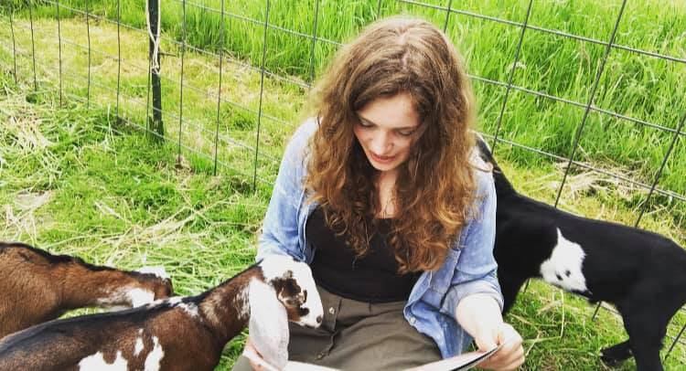
While gatherings are still limited at the libraries, Online Story Time and Crafts are accessible online! We have supply kits for any craft you and your little ones would like to make at home! Email us or call us to make a request for supply kits (Look under Contact Us at the bottom of the newsletter)! Videos are posted every weekend on our Facebook Page (Stockton & Cassadaga Libraries)!

upcoming events This Month:
(All in-person programs, gatherings, clubs, and events hosted, organized or sponsored by the libraries are currently limited at this time).
Weekly:
Online Story Time and Craft Time. Videos posted every weekend on our Facebook Page (Stockton & Cassadaga Libraries)!

Please consider donating to your local library. Any amount helps and is 100% tax deductible.
Contact Us
22 N Main St, PO Box 128, Stockton
595-3323
18 Maple St, PO Box 384, Cassadaga
595-3822
director@stocktonlibraries.org
www.stocktonlibraries.org

