Rural Readings

Mary E SEymour memorial free library & cassadga branch library Newsletter

October 2020
stay safe and healthy!
We want to thank all our patrons for their continued support during this challenging time. Please remember while visiting the libraries to wear a mask, keep 6 feet away from fellow patrons, and to sanitize and wash your hands regularly.
Also, please take note of our return to normal hours:

Mary E. Seymour Memorial Free Library (Stockton):
Tuesday: 1pm-7pm
Thursday: 1pm-7pm
Friday: 1-5pm
Saturday: 10am-2pm

…

Cassadaga Branch Library:
Monday 1pm-7pm
Wednesday: 1pm-7pm
Friday: 9am-12pm
Saturday: 10am-2pm

We want to thank you for all of your continued generosity and support!

W

Recent Events:
RESUMING NORMAL HOURS
We have resumed our normal hours at both libraries. Please take note!
Mary E. Seymour Memorial Free Library:
Tuesday: 1pm-7pm
Thursday: 1pm-7pm
Friday: 1pm-5pm
Sat: 10am-2pm
Cassadaga Branch:
Monday: 1pm-7pm
Wednesday: 1pm-7pm
Friday: 9am-12pm
Saturday: 10am-2pm
ONLINE FUN
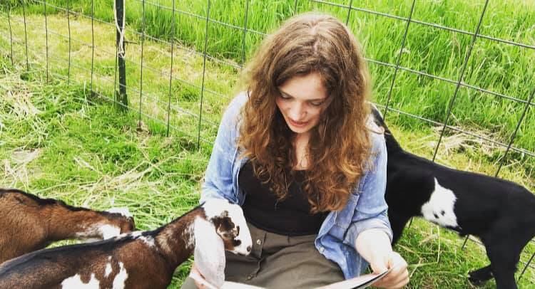
While gatherings are still limited at the libraries, Online Story Time and Crafts are accessible online! We have supply kits for any craft you and your little ones would like to make at home! Email us or call us to make a request for supply kits (Look under Contact Us at the bottom of the newsletter)! Videos are posted every weekend on our Facebook Page (Stockton & Cassadaga Libraries)!

upcoming events This Month:
October 3rd - Cassadaga Book Club will be meeting at 2:00pm at Cassadaga Branch Library. The last book read was ‘The Starless Sea’ by Erin Morgenstern. This is the first meeting since February 2020. The club will be meeting to reestablish meeting times and future book titles to read. Safety measures will be implemented during the meeting, such as wearing a mask, social distancing, and keeping surfaces sanitized. New members welcome!
October 16^{th-} Mary’s Book Club will be meeting at 3:00pm at Cassadaga Branch Library. They are currently reading ‘Sworn to Silence’ by Linda Castillo. The club is currently relocating to Cassadaga Branch Library and will be discussing future meeting details. Safety measures will be implemented during the meeting, such as wearing a mask, social distancing, and keeping surfaces sanitized
October 31st- Be sure to stop at Mary E. Seymour Memorial Free Library (Stockton) and Cassadaga Branch Library before you go out for Trick or Treating this Halloween! From 10:00am – 2:00pm both libraries will be handing out Trick or Treat Bags with candy and goodies. The bags will be big enough to take trick or treating!

Weekly:
Online Story Time and Craft Time. Videos posted every weekend on our Facebook Page (Stockton & Cassadaga Libraries)!

Please consider donating to your local library. Any amount helps and is 100% tax deductible.
Contact Us
22 N Main St, PO Box 128, Stockton
595-3323
18 Maple St, PO Box 384, Cassadaga
595-3822
director@stocktonlibraries.org
www.stocktonlibraries.org

