Rural Readings

Mary E SEymour memorial free library & cassadga branch library Newsletter

NOVEMBER 2020
stay safe and healthy!
We want to thank all our patrons for their continued support during this challenging time. Please remember while visiting the libraries to wear a mask, keep 6 feet away from fellow patrons, and to sanitize and wash your hands regularly.
Also, please take note of our return to normal hours:

Mary E. Seymour Memorial Free Library (Stockton):
Tuesday: 1pm-7pm
Thursday: 1pm-7pm
Friday: 1-5pm
Saturday: 10am-2pm

…

Cassadaga Branch Library:
Monday 1pm-7pm
Wednesday: 1pm-7pm
Friday: 9am-12pm
Saturday: 10am-2pm

We want to thank you for all of your continued generosity and support!

W

Recent Events:
HALLOWEEN TRICK OR TREAT BAGS
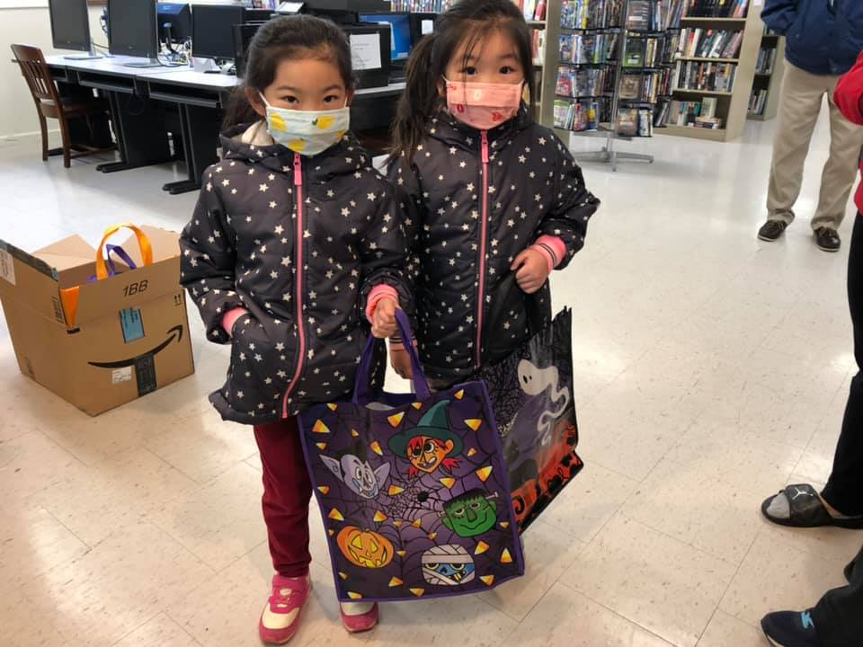
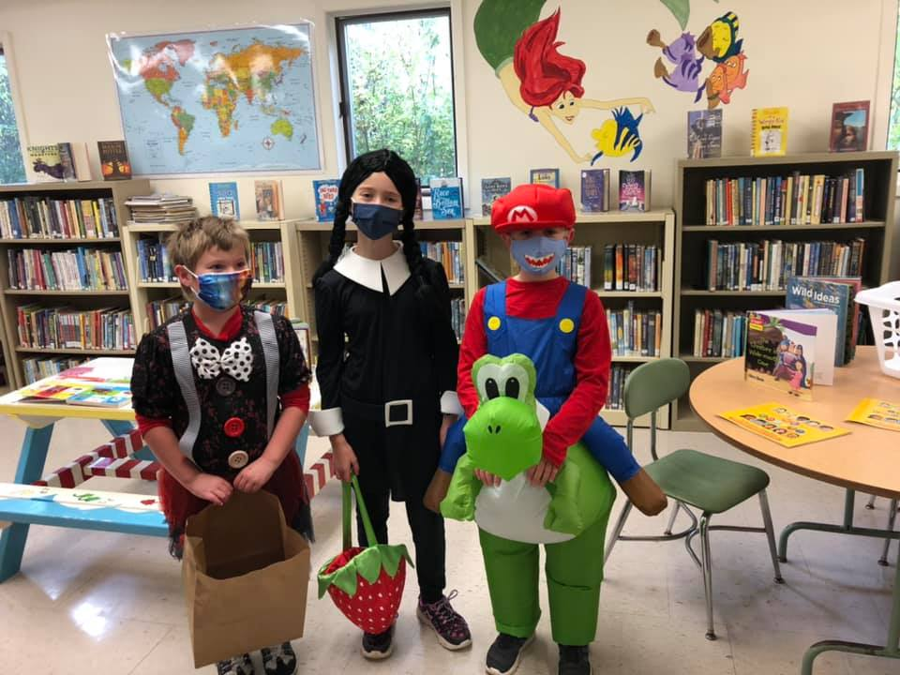
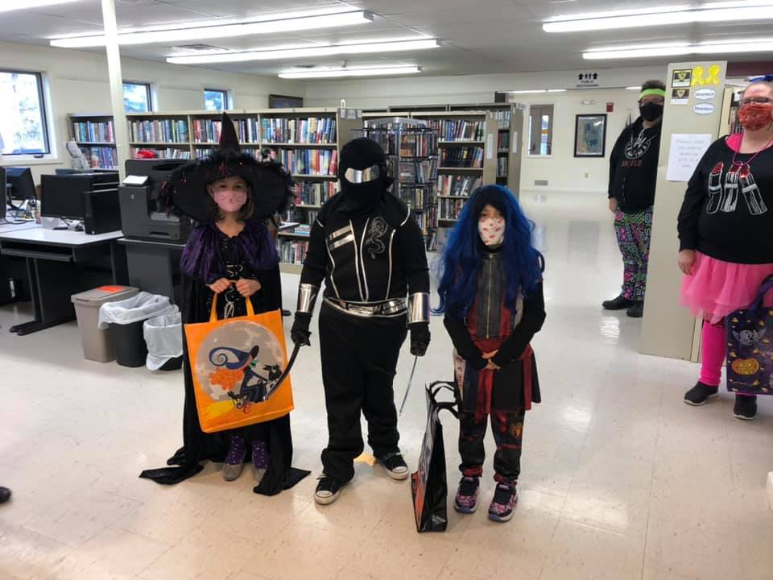
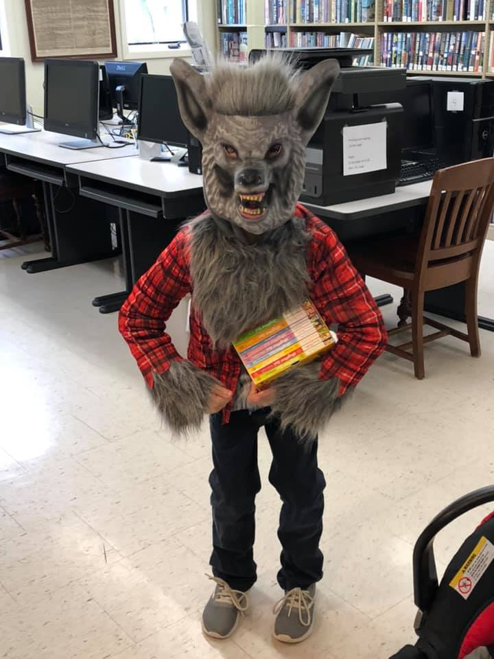
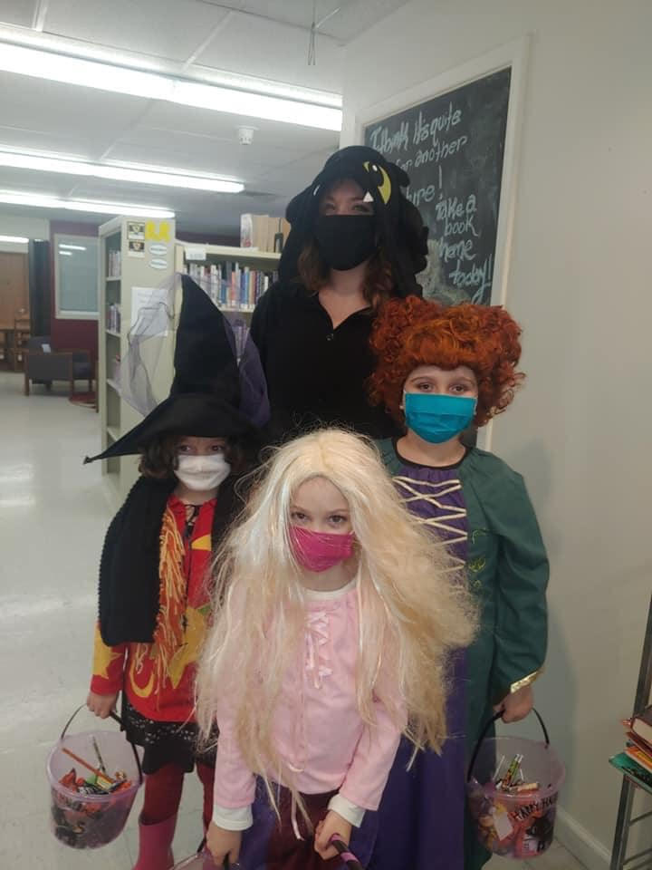
Our libraries were so excited to participate in Halloween this year in some small way by providing Trick or Treat bags to the creative Trick or Treaters of Stockton and Cassadaga. Both libraries handed out bags and goodies from 10am-2pm and had over 100 children and adults stop by throughout the day between the two libraries. Social distancing and sanitization protocols were followed after each visit. While we were sad to not host a Halloween Party like the previous year, it was wonderful to see so many ghouls, monsters, witches, superheroes, soldiers, princesses and so many more visit our libraries.

ONLINE FUN
While gatherings are still limited at the libraries, Online Story Time and Crafts are accessible online! We have supply kits for any craft you and your little ones would like to make at home! Email us or call us to make a request for supply kits (Look under Contact Us at the bottom of the newsletter)! Videos are posted every weekend on our Facebook Page (Stockton & Cassadaga Libraries)!

upcoming events This Month:
November 10^{th-} Board Meeting 10:00am at Cassadaga Branch Library. Safety measures will be implemented during the meeting, such as wearing a mask, social distancing, and keeping surfaces sanitized.
November 18th- Young Adult Book Club *VIRTUAL*. For Middle and High School students of Cassadaga Valley Central Cchool, Hannah Abram of Mary E. Seymour Memorial Free Library/Cassadaga Branch Library and Jessica Huling of Sinclairville Free Library will be hosting a virtual book club at 3:00pm. Students can register with Miss Joslyn and request the book that we will be discussing (“The Lost Girls” by Heather Young) at kjoslyn@cvcougars.org.
November 20th- A Special Thanksgiving Story Time (ft. Lori Cummings). We will be having Thanksgiving themed stories and crafts with special guest, Lori Cummings, at 10:00am at Cassadaga Branch Library. This event is geared toward children 0-7 years of age. REGISTRATION IS REQUIRED. You may register by calling or emailing the contact information below and telling us the name and age of the child who wishes to participate.
November 20th- Mary’s Book Club will be meeting at 3:00pm at Mary E. Seymour Memorial Free Library (In the Conference Room Downstairs). They are currently reading Misc. Bible Fiction by various authors. The next book they will be reading is “Commonwealth” by Ann Patchett. Safety measures will be implemented during the meeting, such as wearing a mask, social distancing, and keeping surfaces sanitized.
November 21st- Cassadaga Book Club will be meeting at 2:00pm at Cassadaga Branch Library. The last book read was “Pretty Monsters” by Kelly Link. The next book to be read is “The Giver of Stars” by Jojo Moyes. Safety measures will be implemented during the meeting, such as wearing a mask, social distancing, and keeping surfaces sanitized. New members welcome!
BOTH LIBRARIES WILL BE CLOSED VETRANS DAY (NOVEMBER 11th) AND NOVEMBER 26th AND 27th FOR THANKSGIVING.
Weekly:
Online Story Time and Craft Time. Videos posted every weekend on our Facebook Page (Stockton & Cassadaga Libraries)!
Please consider donating to your local library. Any amount helps and is 100% tax deductible.
Contact Us
22 N Main St, PO Box 128, Stockton
595-3323
18 Maple St, PO Box 384, Cassadaga
595-3822
director@stocktonlibraries.org
www.stocktonlibraries.org

