Rural Readings

Mary E SEymour memorial free library & cassadga branch library Newsletter

DECEMBER 2020
stay safe and healthy!
We want to thank all our patrons for their continued support during this challenging time. Please remember while visiting the libraries to wear a mask, keep 6 feet away from fellow patrons, and to sanitize and wash your hands regularly.
Also, please take note of our return to normal hours:

Mary E. Seymour Memorial Free Library (Stockton):
Tuesday: 1pm-7pm
Thursday: 1pm-7pm
Friday: 1-5pm
Saturday: 10am-2pm

…

Cassadaga Branch Library:
Monday 1pm-7pm
Wednesday: 1pm-7pm
Friday: 9am-12pm
Saturday: 10am-2pm

We want to thank you for all of your continued generosity and support!

W

Fundraising For Solar Panels:
Village Residents,
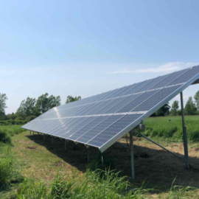
WE NEED YOUR HELP!!!
Our libraries were fortunate enough to receive a construction grant of $62,697, before New York State virtually shut down because of Covid-19. This construction grant is contingent on us contributing 25% of the cost of the project. Our project consists of an $83,596 Solar Electric Panel Installation, High Efficiency AC/Heat Pump System and Signage for our Stockton site. We are expected to contribute $20,899 of which we have currently secured roughly $9,240. In order to receive the grant money and bring this project to fruition, we need to raise another $11,659. We humbly ask you to help us meet this challenge! Our grant will bring renewable energy to our community and help our libraries to stay open and make a difference now and for future generations.
To make a charitable and tax deductible donation you may mail in cash or check made out to Mary E. Seymour Memorial Free Library. To donate online, you may click the DONATE button at the bottom of our website: www.stocktonlibraries.org or visit our GoFundMe page to keep up with the project, the link is available on our website and Facebook Page: Stockton & Cassadaga Libraries.
ONLINE FUN
While gatherings are still limited at the libraries, Online Story Time and Crafts are accessible online! We have supply kits for any craft you and your little ones would like to make at home! Email us or call us to make a request for supply kits (Look under Contact Us at the bottom of the newsletter)! Videos are posted every weekend on our Facebook Page (Stockton & Cassadaga Libraries)!

upcoming events This Month:
December 3^{rd -} Friends of Library will be meeting at 1:00pm (following all Covid-19 Health Guidelines) to decorate Cassadaga Branch Library for Christmas!
December 5th- Light Up Cassadaga. Our libraries will be participating in CBC’s Annual Light Up Cassadaga from 3:30pm-6:00pm in Cassadaga Village Commons. The event features Santa in the park, treats, games, a living Nativity, cocoa, giveaways, free books, caroling, and more. A mask is required for all in attendance.
December 9th- Board Meeting 10:00am at Cassadaga Branch Library. Safety measures will be implemented during the meeting, such as wearing a mask, social distancing, and keeping surfaces sanitized. A Zoom Meeting is being considered due to a spike in recent Covid-19 cases.
December 16th- Young Adult Book Club *VIRTUAL*. For Middle and High School students of Cassadaga Valley Central Cchool, Hannah Abram of Mary E. Seymour Memorial Free Library/Cassadaga Branch Library and Jessica Huling of Sinclairville Free Library will be hosting a virtual book club at 3:00pm. Students can register with Miss Joslyn and request the book that we will be discussing.
December 18th- Mary’s Book Club will be meeting at 3:00pm at Mary E. Seymour Memorial Free Library (In the Conference Room Downstairs). They are currently reading “Commonwealth” by Ann Patchett, the next book they will be reading is misc. Christmas titles by various authors. Safety measures will be implemented during the meeting, such as wearing a mask, social distancing, and keeping surfaces sanitized.
Cassadaga Book Club will not be meeting this month. They plan to meet January 16th next month at 2:00pm. They are currently reading “The Giver of Stars” by Jojo Moyes. They will be reading “Spider’s Web” by Agatha Christie
BOTH LIBRARIES WILL BE CLOSED FOR CHRISTMAS (DECEMBER 24th-27th) AND NEW YEARS (DECEMBER 31st- JANUARY 3rd)
Weekly: Online Story Time and Craft Time. Videos posted every weekend on our Facebook Page (Stockton & Cassadaga Libraries)!
Please consider donating to your local library. Any amount helps and is 100% tax deductible.
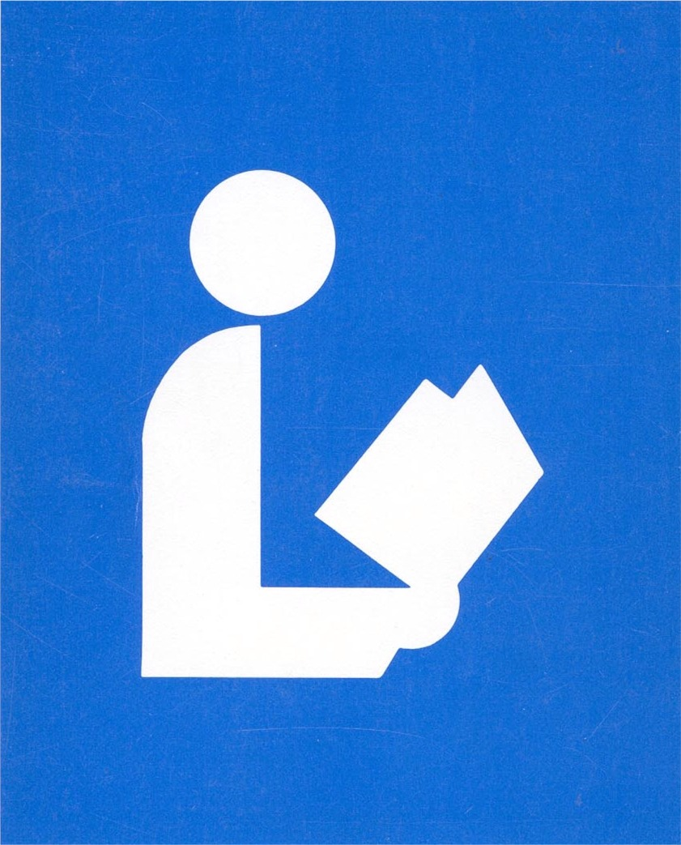
Contact Us
22 N Main St, PO Box 128, Stockton
595-3323
18 Maple St, PO Box 384, Cassadaga
595-3822
director@stocktonlibraries.org
www.stocktonlibraries.org

