Rural Readings

Mary E SEymour memorial free library & cassadaga branch library Newsletter

June 2021
Covid-19 Guidelines to be Discussed
We want to thank all our patrons for their continued support during this challenging time. Decisions concerning the recent changes in Covid-19 Guidelines will be discussed at our next Board Meeting, June 8th.
Currently we ask ALL patrons to continue to wear a mask in our libraries.
Also, please take note our current hours:
Mary E. Seymour Memorial Free Library (Stockton):
Tuesday: 1pm-7pm
Thursday: 1pm-7pm
Friday: 1-5pm
Saturday: 10am-2pm
…
Cassadaga Branch Library:
Monday 1pm-7pm
Wednesday: 1pm-7pm
Friday: 9am-12pm
Saturday: 10am-2pm

We want to thank you for all of your continued generosity and support!

W

First Annual Cassadaga Running Festival Proceeds Going to Libraries:
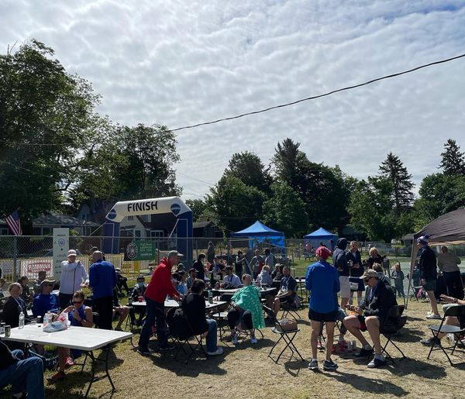
The Board, Staff and Volunteers of Mary E. Seymour Memorial Free Library and Cassadaga Branch Library were very moved by the success of the First Annual Cassadaga Running Festival that took play Sunday, May 30th, on Memorial Day Weekend. The event was organized by Wilson Endurance Sports with the help of the libraries’ Board of Trustees, the libraries’ staff and the Friends of the Library Association. All proceeds from the race went to the libraries. Threre was a wonderful turnout with over 200 runners participating. With onsite food, live music, and a beer tent, the event was a wonderful way to bring the community together to start the summer!
Story Time Starts Again In-Person:
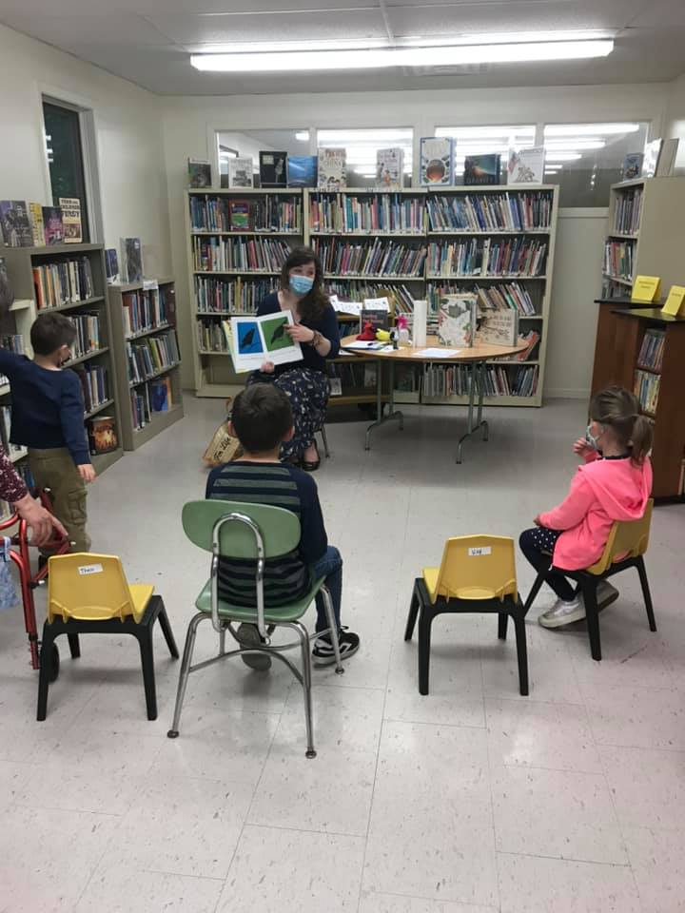
In-Person Story Time is being hosted at Cassadaga Branch Library again! This is the first time since March 2020 that we have met and we are so excited to be reading and crafting with our young patrons again! Please see back of the newsletter for more details.
upcoming Programs and Events:
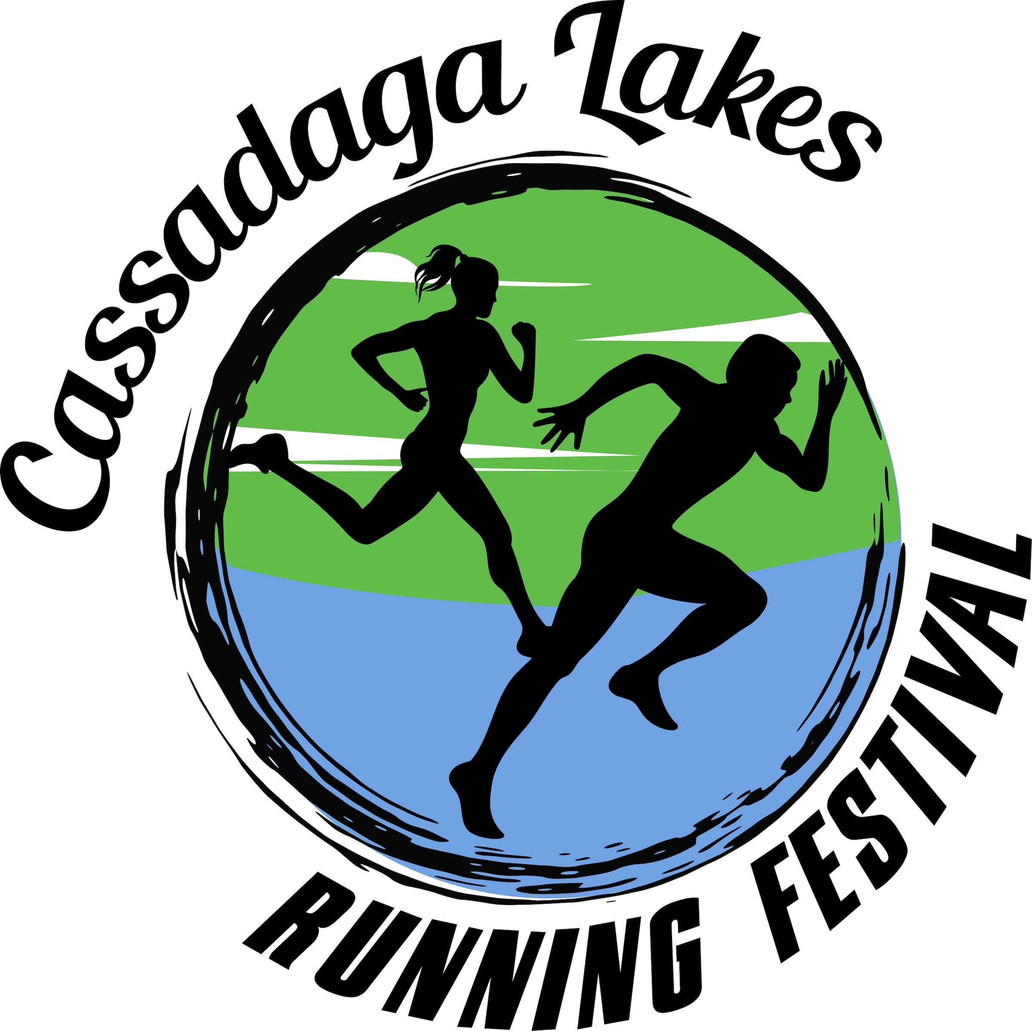
May 30, 2021
Support our libraries by participating in a Marathon, Half Marathon, 10k, 5k, or 1 Mile Race!
Race will start and finish at the Cassadaga Beach on Park Avenue, Cassadaga, NY
All proceeds go to benefiting Mary E. Seymour Memorial Free Library and Cassadaga Branch Library
Actively seeking Walkers/Runners, Volunteers, and Sponsors. Ask us how you can help at the front desks of our libraries!
Register to race @ www.coarchmarkwilson.com

Monthly:
June 8th – Board of Trustees Meeting 10:00am at Cassadaga Branch Library.
June 17th- Cassadaga Book Club will be meeting at Cassadaga Branch Library at 4:30pm. They are presently reading “A Team of Rivals: The Political Genius of Abraham Lincoln” by Doris Kearns Goodwin and will be discussing this book. Books can be picked up at Cassadaga Branch Library. Their next read will be “At Water’s Edge” by Sara Gruen.
June 18th- Mary’s Book Club will be meeting at Stockton in the downstairs Town Board Meeting Room at 3pm. They will be discussing “The Queen’s Secret” by Karen Harper. Their next read will be “Wild Mountain Time” by Rosamunde Pilcher.
Weekly:
IN-PERSON STORY TIME! Miss Hannah will be hosting Story Time at Cassadaga Branch Library on FRIDAYS at 10:30 AM. There will be reading out loud, singing songs, and a take home craft at the end. Masks are required for children over 3 years of age. ALL CHILDREN MUST REGISTER FOR THIS PROGRAM! To register, email director@stocktonlibraries with child’s name and age. We will be reading outdoors as much as possible. With child’s registration, parents and guardians will receive the new rules and guidelines for a safe and fun Story Time.
Summer Reading Program: Our Summer Reading Program will be beginning July 5th! Please Email director@stocktonlibraires.org to sign up and for more information.

Please consider donating to your local library. Any amount helps and is 100% tax deductible.

Contact Us
22 N Main St, PO Box 128,
Stockton, NY
14784
716-595-3323
18 Maple St, PO Box 384,
Cassadaga, NY 14718
716-595-3822
director@stocktonlibraries.org
www.stocktonlibraries.org

